Ibrahim Qasim
G R A P H I C & U I / U X D E S I G N E R

G R A P H I C D E S I G N E R

EDUCATION
Bachelor’s Degree — Computer science
AUP,
2020 – 2024
Intermediate
ICMS, Peshawar 2018 – 2020

EXPERTISE

Graphic Design UI/UX Design
Brand Identity & Logo Social Media Design E-commerce Design AI-Powered Creative
Video Editing

PROFILE
Graphic & UI/UX Designer with 3+ years of experience in visual design, branding, social media creatives, and user interface design. Skilled in Adobe Creative Suite, Figma, Canva, Shopify, and AI-powered creative tools, with a strong focus on clean, modern, and user-friendly designs.

WORK EXPERIENCE

Graphic & UI/UX Designer
Present AI Digital System - Peshawar, KPk
Created graphics, UI/UX designs, social media creatives, animations, and digital content using Adobe Creative Suite, Figma, Canva, Shopify, and AI tools.

Graphic Designer
2025 – 2026 EraXpert Innovations
Designed social media posts, banners, marketing materials, brand assets, and digital creatives for various campaigns and business projects.

Graphic & UI/UX Designer
Present Freelance
Created logos, social media designs, banners, websites, UI/UX layouts, product graphics, and branding materials for different clients.

E-commerce Designer

2023 – Presnet Freelance

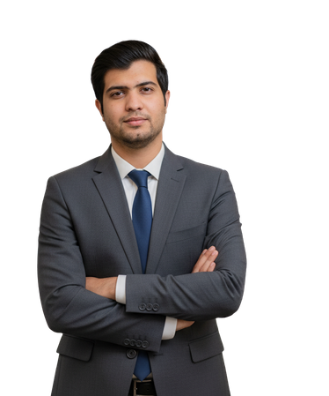





Phone
+92 304 5071316

Email
bangashibrahim2100@gmail.com

Area
Peshawar, KPK, Pakistan
Designed and customized Shopify storefronts, product pages, banners, collections, and visual elements to improve brand presentation.

DESIGN THAT CONNECTS
create purposeful designs that connect brands with their audiences through strong visuals, thoughtful layouts, and intuitive user experiences. My approach combines creativity, usability, and modern design tools to turn ideas into meaningful digital experiences.

